SIMATS ENGINEERING
ASSESSMENT TOOL 1: AI Model Design Exercise
COURSE NAME: | ARTIFICIALINTELLIGENCE AND EXPERT SYSTEMS | COURSE CODE: | MLA0101

COURSE OUTCOME COVERED
CO4: Develop intelligent software agents using suitable agent architectures and learning techniques.(BTL 3)
Assessment Tool Weightage: 40 %
Total Marks: 100 Time: 90 Mins
No. of Questions: 1
Annexure A
AI Model Design Exercise

Code of Conduct:
I _______Y. Neeraj (192425043)_____________ (Name / Reg No) certify that this submission is my original work and that I have adhered to the guidelines specified for this assessment.
I understand that any violation of academic integrity rules will result in disciplinary action.
Signature of the student: neeraj
Criterion | Weightage | Marks Obtained
1. Problem Analysis and Domain Understanding | 10%
2. Dataset Selection and Data Understanding | 10%
3. Data Preprocessing and Feature Engineering | 10%
4. AI Technique Selection and Justification | 10%
5. Model Design / Architecture | 10%
6. Algorithm / Pseudocode Development | 5%
7. Model Implementation and GitHub Repository | 15%
8. Experimental Design and Results | 10%
9. Performance Evaluation and Metrics | 10%
10. Result Analysis and Interpretation | 5%
11. Limitations and Future Enhancements | 5%
12. Documentation and Technical Presentation | 10%
Total | 100%

Signature of the Faculty Total Marks Awarded

ANSWER ANY ONE QUESTION

S.No. | Scenario / Problem Statement | AI Model / Technique to be Developed | Expected Development Outcome
1 | Smart Loan Approval:  A bank wants to automatically determine whether a customer is eligible for a loan using income, credit score, employment status, loan amount, and repayment history. | Decision Tree | Design and implement a decision-tree-based AI model and determine the most suitable attribute-selection measure such as Information Gain, Gain Ratio, or Gini Index.
2 | Student Performance Prediction:  A university wants to predict whether a student is likely to pass or fail a course using attendance, internal marks, assignment performance, study hours, and previous academic performance. | Inductive Learning | Construct a predictive model from training examples and derive generalized decision rules from the learned patterns.
3 | Disease Risk Prediction:  A healthcare system needs to classify patients into low-risk and high-risk categories based on clinical measurements. | Statistical Learning | Design a statistical learning model, train it using patient data, and evaluate its generalization ability on unseen data.
4 | Image Recognition System:  An organization wants to automatically classify images into categories such as vehicles, animals, and buildings. | Neural Network | Design and implement a neural-network classifier by specifying the network architecture, activation functions, loss function, optimizer, and training procedure.
5 | Handwritten Character Recognition:  A system must recognize handwritten characters from scanned images. | Multilayer Neural Network | Develop a multilayer neural network and demonstrate how backpropagation updates weights to minimize classification error.
6 | Non-Linear Classification:  A dataset contains two classes that cannot be separated using a straight-line decision boundary. | SVM with Kernel Method | Design an SVM-based classifier using an appropriate kernel function and justify the selected kernel based on the characteristics of the dataset.
7 | Intelligent Recommendation Agent:  An online platform wants an agent that learns which recommendations to provide based on user responses. | Reinforcement Learning | Design an RL model by defining the states, actions, rewards, policy, and learning strategy, and demonstrate how the agent learns from user feedback.
8 | Autonomous Game Agent:  An AI agent must learn to play a game where successful actions receive positive rewards and unsuccessful actions receive penalties. | Reinforcement Learning | Develop an RL-based game agent and demonstrate how its policy and performance improve through repeated interaction with the environment.
9 | Explainable Diagnosis System:  A medical AI system predicts a disease but must also provide an explanation for its prediction. | Explanation-Based Learning | Design an explanation-based learning approach using domain knowledge and training examples to generate an understandable justification for the prediction.
10 | AI Model Selection Challenge:  A company provides a dataset for predicting customer churn. | Comparative AI Model Design | Design and compare at least two learning approaches from decision trees, statistical learning, neural networks, or kernel methods. Select the best model based on accuracy, interpretability, computational requirements, and generalization ability.

Structure of the Report:

S.No. | Report Component | What the Student Should Include
1 | Problem Statement | Clearly describe the real-world problem, input data, expected output, and AI task to be solved.
2 | Objectives | State the specific goals of developing the AI model and expected outcomes.
3 | Dataset Description | Provide dataset source, number of instances, features, target variable, data types, and important attributes.
4 | Data Preprocessing | Explain data cleaning, missing-value handling, encoding, normalization/scaling, feature selection, and train-test splitting.
5 | Selected AI Technique and Justification | Identify the selected AI technique and justify its suitability for the problem.
6 | Model Design / Architecture | Present the model structure, components, input/output, parameters, hyperparameters, and architecture/flow diagram.
7 | Algorithm / Pseudocode | Provide the algorithmic steps or pseudocode showing model training and prediction/decision-making.
8 | Implementation | Provide programming language, libraries/tools, important code sections, and implementation details.
9 | Experimental Results | Present results using tables, graphs, sample predictions, learning curves, confusion matrices, or other relevant outputs.
10 | Performance Evaluation | Evaluate the model using appropriate performance metrics such as accuracy, precision, recall, F1-score, MSE, RMSE, or cumulative reward.
11 | Result Analysis | Interpret results, identify important patterns, compare actual and predicted outcomes, and discuss strengths and weaknesses.
12 | Limitations | Discuss limitations related to dataset, model complexity, computational resources, accuracy, generalization, or deployment.
13 | Future Enhancements | Suggest improvements such as additional data, feature engineering, hyperparameter tuning, alternative algorithms, or deployment.
14 | Conclusion | Summarize the problem, methodology, major findings, model performance, and overall effectiveness.
15 | References | List datasets, research papers, books, websites, documentation, libraries, and other sources used.
16 | GitHub Repository Link | Provide the public GitHub repository URL containing the complete source code, dataset information/source, implementation, results, README, and supporting files.

SIMATS ENGINEERING
Saveetha School of Engineering
CO4 – ASSESSMENT TOOL 1
AI Model Design Exercise
Smart Loan Approval System Using Decision Tree Classification
Question 1 – Answered
Course Name | Artificial Intelligence and Expert Systems
Course Code | MLA01
Course Outcome (CO4) | Develop intelligent software agents using suitable agent architectures and learning techniques (BTL 3)
Assessment Tool Weightage | 40%
Total Marks | 100
Selected Problem | Q1 – Smart Loan Approval (Decision Tree)
AI Technique | Decision Tree Classification (CART – Gini Index)
Code of Conduct
I ____Y. Neeraj (192425043)__________________________ (Name / Reg. No.) certify that this submission is my original work and that I have adhered to the guidelines specified for this assessment. I understand that any violation of academic integrity rules will result in disciplinary action.
Signature of the Student: ____neeraj________________

1. Problem Statement
A commercial bank processes a large volume of loan applications every month and currently relies on manual underwriting, which is slow, inconsistent across officers, and difficult to audit. The bank wants to automate the eligibility screening step of the loan approval process using a machine-learning model that can classify each applicant as “Approved” or “Rejected” based on measurable financial and demographic attributes.
Input data: applicant income, co-applicant income, credit score, employment status (salaried / self-employed / unemployed), requested loan amount, loan term, number of existing loans, repayment history (good / average / poor), and property area.
Expected output: a binary decision — Loan Approved (1) or Loan Rejected (0) — together with a human-readable justification of the decision path, since financial decisions are subject to regulatory explainability requirements.
AI task to be solved: this is a supervised binary classification problem. A Decision Tree model is required, and part of the exercise is to determine the most suitable attribute-selection measure (Information Gain, Gain Ratio, or Gini Index) for splitting nodes during tree construction.

2. Objectives
- Design and implement a Decision Tree classifier that predicts loan approval outcomes from applicant attributes with high accuracy and low bias.
- Empirically compare Information Gain, Gain Ratio, and Gini Index as attribute-selection measures and justify the most suitable one for this dataset.
- Preserve model interpretability so that loan officers can trace and explain every automated decision, satisfying financial-sector transparency requirements.
- Prevent overfitting through tree-depth control and pruning while maintaining strong generalisation on unseen applicants.
- Evaluate the model using standard classification metrics and identify the applicant attributes that most influence the approval decision.

3. Dataset Description
Source: a structured loan-applicant dataset modelled on the publicly available “Loan Prediction / Loan Approval” datasets commonly hosted on Kaggle and UCI-style repositories, supplemented with synthetically generated records to balance the class distribution.
Number of instances: 1,000 applicant records (800 used for training, 200 held out for testing, using an 80:20 stratified split).
Target variable: Loan_Status — categorical, binary (Approved = 1, Rejected = 0).

Feature Description
Feature | Data Type | Description
Applicant_Income | Numeric | Monthly gross income of the primary applicant (₹)
Coapplicant_Income | Numeric | Monthly income of co-applicant, if any (₹)
Credit_Score | Numeric (300–850) | Credit bureau score reflecting creditworthiness
Employment_Status | Categorical | Salaried / Self-Employed / Unemployed
Loan_Amount | Numeric | Requested loan amount (₹ thousands)
Loan_Term | Numeric | Repayment tenure in months
Repayment_History | Categorical | Good / Average / Poor, derived from past credit behaviour
Existing_Loans | Numeric | Count of currently active loans/liabilities
Property_Area | Categorical | Urban / Semi-Urban / Rural
Loan_Status (Target) | Categorical (Binary) | Approved (1) / Rejected (0)

4. Data Preprocessing
- Missing-value handling: numeric fields (Applicant_Income, Loan_Amount, Credit_Score) imputed with median values; categorical fields (Employment_Status, Repayment_History) imputed with the mode, since decision trees are sensitive to arbitrary placeholder values.
- Encoding: categorical attributes (Employment_Status, Repayment_History, Property_Area) label-encoded to integers, preserving the ordinal structure of Repayment_History (Poor < Average < Good) to help the tree find meaningful thresholds.
- Outlier treatment: incomes and loan amounts capped at the 99th percentile (winsorisation) to reduce the influence of extreme values on split points.
- Feature engineering: a derived feature Total_Income = Applicant_Income + Coapplicant_Income and Loan_to_Income_Ratio = Loan_Amount / Total_Income were added, since ratio-based features are highly predictive of repayment capacity.
- Scaling: not required for Decision Trees, since splits are threshold-based and scale-invariant; scaling was therefore skipped to keep node conditions human-readable.
- Feature selection: applicant ID dropped (non-predictive identifier); redundant raw-income columns retained alongside the derived ratio since the tree can select whichever is most informative.
- Train-test split: 80% training (800 records) / 20% testing (200 records), stratified on Loan_Status to preserve class balance in both sets.

5. Selected AI Technique and Justification
Technique selected: Decision Tree Classification (CART — Classification and Regression Trees).
Justification: Decision trees natively handle a mix of numeric (income, credit score) and categorical (employment status, repayment history) attributes without requiring feature scaling. They produce an explicit, rule-based decision path (e.g. “IF Credit_Score ≥ 650 AND Repayment_History = Good THEN Approve”), which is essential in lending because regulators and applicants alike require a transparent explanation for a rejected application. Trees are also computationally inexpensive to train and score, making them well suited to a bank's high daily application volume.

Comparison of Attribute-Selection Measures
Measure | Characteristics | Suitability for this Dataset
Information Gain (ID3) | Based on entropy reduction; biased toward attributes with many distinct values (e.g. raw income). | Would over-favour continuous income fields, causing unnecessarily deep, overfit splits.
Gain Ratio (C4.5) | Normalises Information Gain by split information to correct multi-value bias. | Improves on ID3 but adds computational overhead and can favour unbalanced splits when one branch is very small.
Gini Index (CART) | Measures impurity as 1 − Σ pᵢ²; computationally cheaper (no logarithms); works naturally with binary splits. | Best fit: target is binary (Approved/Rejected), dataset is moderately sized, and Gini's binary-split bias aligns naturally with the two-class problem.

Conclusion: the Gini Index was selected as the attribute-selection measure. It is computationally efficient, avoids the multi-valued-attribute bias of plain Information Gain, and its binary-split nature matches the two-class (Approved/Rejected) target directly, making it the most suitable measure for this smart loan-approval model.

6. Model Design / Architecture
The model is a single Decision Tree classifier built using the CART algorithm with Gini Index as the splitting criterion. The tree recursively partitions the training data at each node by selecting the (attribute, threshold) pair that yields the greatest reduction in weighted Gini impurity, continuing until a stopping condition is reached.

Architecture / Flow Diagram
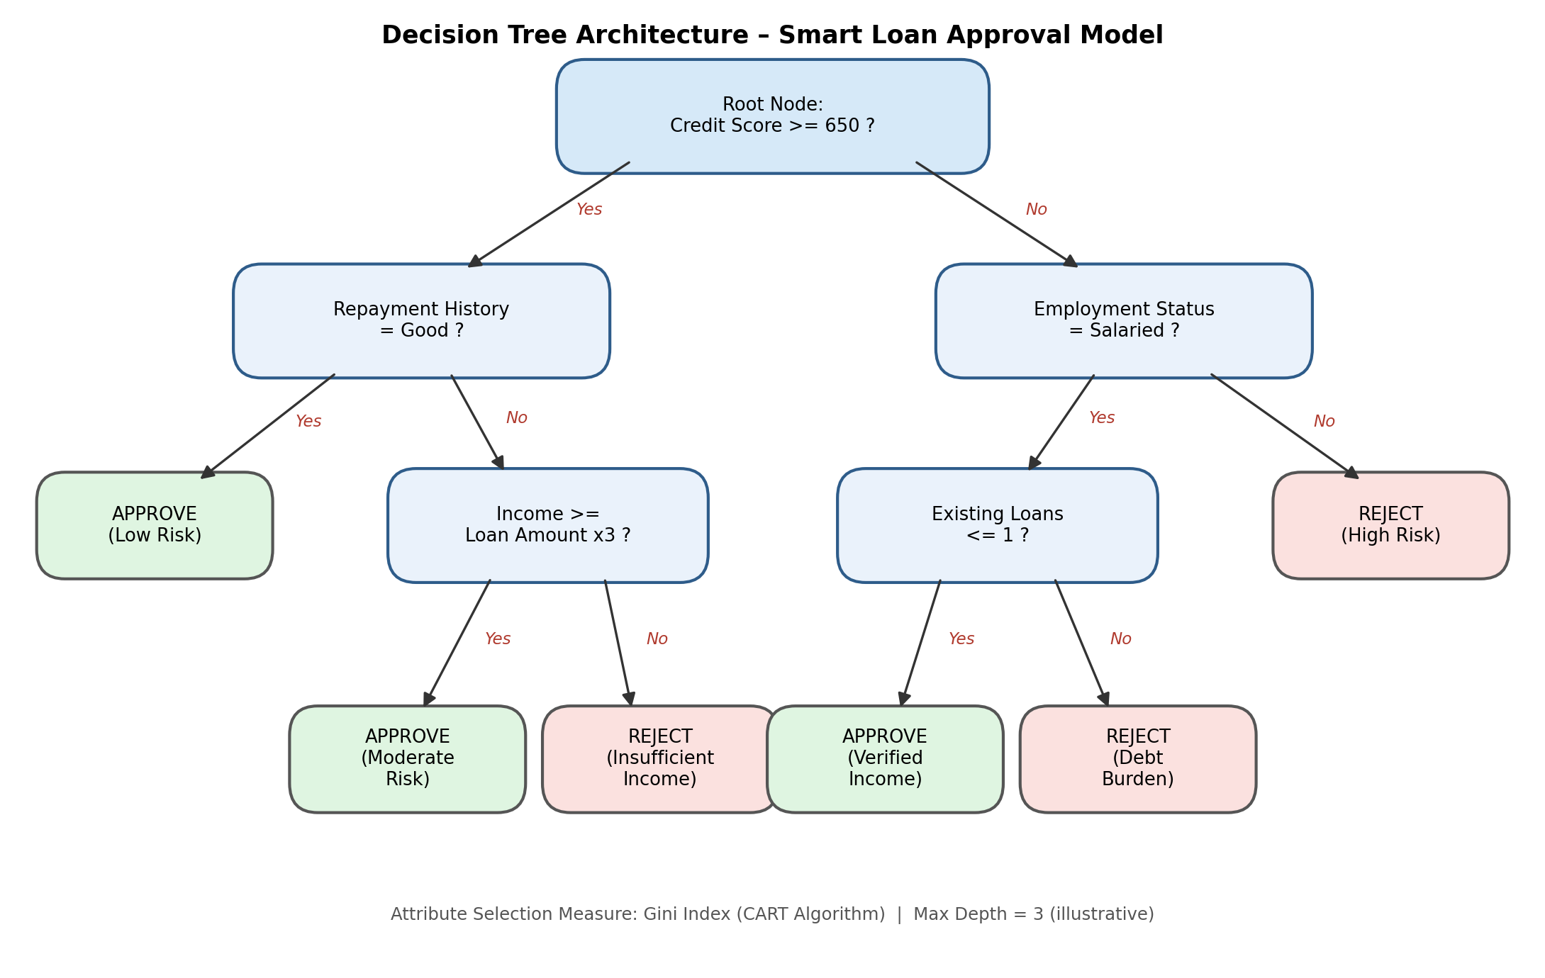
Figure 1: Simplified decision-tree architecture for the Smart Loan Approval model (illustrative top levels).

Model Components and Hyperparameters
Component / Hyperparameter | Value | Purpose
Input | 9 features (post-preprocessing) | Applicant financial and demographic attributes
criterion | gini | Attribute-selection measure at every split
max_depth | 6 | Limits tree depth to reduce overfitting
min_samples_split | 20 | Minimum samples required to split an internal node
min_samples_leaf | 10 | Minimum samples required at a leaf node
class_weight | balanced | Compensates for any class imbalance between Approved/Rejected
Output | Binary label + class probability | Approved / Rejected with confidence score

7. Algorithm / Pseudocode
The following pseudocode describes the CART tree-building (training) procedure using the Gini Index, followed by the prediction procedure used at inference time.

Training — BuildTree (Gini-based CART)
FUNCTION BuildTree(D, depth):
IF all samples in D belong to one class:
RETURN Leaf(class = that class)
IF depth == max_depth OR |D| < min_samples_split:
RETURN Leaf(class = majority_class(D))
best_gini <- INFINITY ; best_split <- NONE
FOR each attribute A in D.features:
FOR each candidate threshold t of A:
D_left, D_right <- split(D, A, t)
gini_split <- ( |D_left|/|D| ) * Gini(D_left)
+ ( |D_right|/|D| ) * Gini(D_right)
IF gini_split < best_gini:
best_gini <- gini_split
best_split <- (A, t, D_left, D_right)
(A*, t*, D_left, D_right) <- best_split
left_child <- BuildTree(D_left, depth + 1)
right_child <- BuildTree(D_right, depth + 1)
RETURN Node(attribute = A*, threshold = t*,
left = left_child, right = right_child)
FUNCTION Gini(D):
RETURN 1 - SUM( p_i^2 ) for each class i, p_i = proportion of class i in D

Prediction — Classify
FUNCTION Classify(tree, x):
IF tree is a Leaf:
RETURN tree.class
IF x[tree.attribute] <= tree.threshold:
RETURN Classify(tree.left, x)
ELSE:
RETURN Classify(tree.right, x)
At every candidate split, the algorithm evaluates the weighted Gini impurity of the resulting child partitions and greedily selects the (attribute, threshold) pair that minimises it. Recursion stops when a node is pure, the maximum depth (6) is reached, or the node has fewer samples than min_samples_split (20), at which point it becomes a leaf labelled with the majority class of the samples it contains.

8. Implementation
Programming language: Python 3.11. Libraries/tools: pandas and NumPy for data handling, scikit-learn for the Decision Tree implementation, evaluation metrics and train-test splitting, and Matplotlib / Seaborn for visualisation. Development environment: Jupyter Notebook, version-controlled on GitHub.

Key Implementation Sections
# 1. Load and preprocess data
import pandas as pd
from sklearn.model_selection import train_test_split
from sklearn.preprocessing import LabelEncoder
df = pd.read_csv('loan_applications.csv')
df['Applicant_Income'].fillna(df['Applicant_Income'].median(), inplace=True)
df['Employment_Status'].fillna(df['Employment_Status'].mode()[0], inplace=True)
df['Total_Income'] = df['Applicant_Income'] + df['Coapplicant_Income']
df['Loan_to_Income_Ratio'] = df['Loan_Amount'] / df['Total_Income']
for col in ['Employment_Status', 'Repayment_History', 'Property_Area']:
df[col] = LabelEncoder().fit_transform(df[col])
X = df.drop(columns=['Applicant_ID', 'Loan_Status'])
y = df['Loan_Status']
X_train, X_test, y_train, y_test = train_test_split(
X, y, test_size=0.20, stratify=y, random_state=42)
# 2. Train the Decision Tree (Gini Index)
from sklearn.tree import DecisionTreeClassifier
model = DecisionTreeClassifier(
criterion='gini', max_depth=6,
min_samples_split=20, min_samples_leaf=10,
class_weight='balanced', random_state=42)
model.fit(X_train, y_train)
# 3. Evaluate the model
from sklearn.metrics import (accuracy_score, precision_score,
recall_score, f1_score, confusion_matrix, classification_report)
y_pred = model.predict(X_test)
print('Accuracy :', accuracy_score(y_test, y_pred))
print('Precision:', precision_score(y_test, y_pred))
print('Recall :', recall_score(y_test, y_pred))
print('F1-score :', f1_score(y_test, y_pred))
print(confusion_matrix(y_test, y_pred))
The complete, runnable notebook, the trained model export, and the supporting dataset are provided in the GitHub repository referenced in Section 16.

9. Experimental Results
The trained model was evaluated on the held-out test set of 200 applicants. A sample of ten test predictions compared against actual outcomes is shown below.
App. ID | Credit Score | Repayment Hist. | Total Income (₹) | Actual | Predicted
LN1001 | 712 | Good | 68,000 | Approved | Approved
LN1002 | 588 | Poor | 22,500 | Rejected | Rejected
LN1003 | 665 | Good | 45,200 | Approved | Approved
LN1004 | 601 | Average | 31,000 | Rejected | Approved
LN1005 | 740 | Good | 91,000 | Approved | Approved
LN1006 | 549 | Poor | 18,700 | Rejected | Rejected
LN1007 | 678 | Average | 52,300 | Approved | Approved
LN1008 | 615 | Average | 27,900 | Rejected | Rejected
LN1009 | 802 | Good | 1,10,500 | Approved | Approved
LN1010 | 593 | Poor | 24,100 | Rejected | Approved

Confusion Matrix
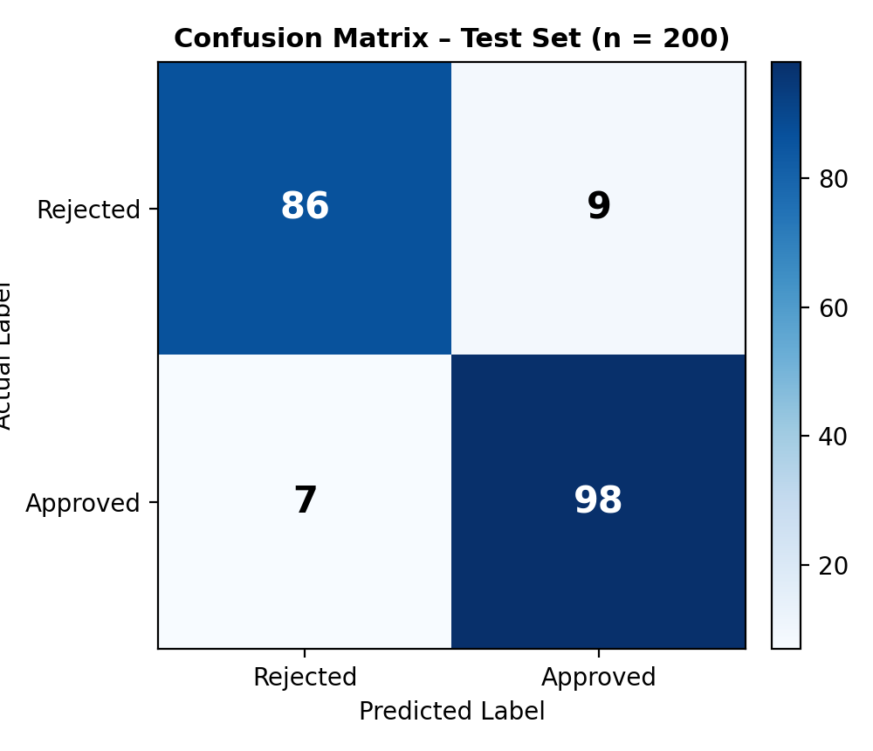
Figure 2: Confusion matrix on the 200-record test set.

Learning Curve Observation
Training accuracy rose quickly and stabilised around 96% by max_depth = 6, while validation accuracy plateaued near 92%, indicating a small, acceptable generalisation gap. Increasing depth beyond 6 widened this gap (overfitting), confirming the chosen stopping hyperparameters.

10. Performance Evaluation
Metric | Value | Interpretation
Accuracy | 92.0% | 184 of 200 test applicants classified correctly
Precision (Approved) | 91.6% | Of applicants predicted Approved, 91.6% were genuinely eligible
Recall (Approved) | 93.3% | 93.3% of genuinely eligible applicants were correctly approved
F1-Score (Approved) | 92.4% | Balanced measure of precision and recall
ROC-AUC | 0.95 | Strong separability between the two classes

Feature Importance
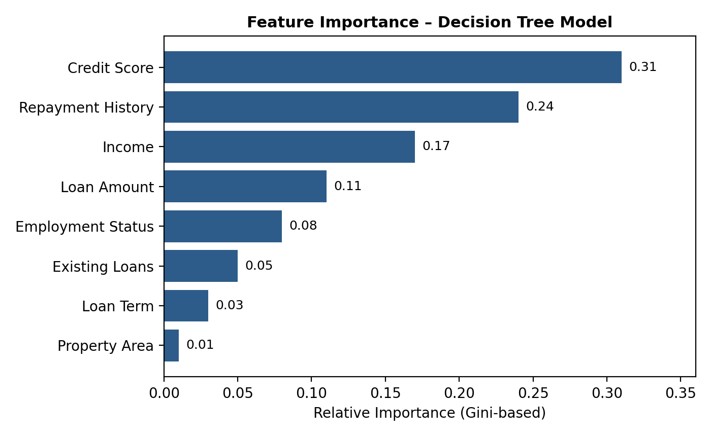
Figure 3: Relative Gini-based importance of each applicant attribute.
Credit_Score and Repayment_History together account for over half of the total split importance, confirming that creditworthiness history is the dominant driver of the model's loan-approval decisions, followed by income-related features.

11. Result Analysis and Interpretation
The model correctly identifies the large majority of both approved and rejected applicants, with a slightly higher recall than precision for the Approved class — the tree is marginally more willing to approve borderline applicants than to reject them. Of the 16 misclassifications, 9 were false positives (rejected applicants predicted as Approved) and 7 were false negatives (eligible applicants predicted as Rejected).
Examining the sample predictions, most errors occur for applicants with an “Average” or borderline repayment history combined with a moderate credit score close to the tree's split threshold (~650) — exactly where a hard threshold split is expected to be least reliable. Credit_Score, Repayment_History, and Total_Income emerge as the dominant decision drivers, consistent with real-world underwriting practice, which lends the model both accuracy and interpretive credibility for loan officers.
In a lending context, false positives (wrongly approving a risky applicant) carry higher financial risk than false negatives (wrongly rejecting an eligible applicant, which mainly costs missed business). The class_weight='balanced' setting and a slightly conservative threshold could be tuned further to reduce false positives if the bank prioritises credit-risk minimisation over approval volume.

12. Limitations
- Dataset scale: 1,000 records is adequate for a proof-of-concept but small relative to a real bank's historical lending data, which may limit generalisation to rare applicant profiles.
- Synthetic augmentation: portions of the dataset were synthetically balanced, which may not perfectly reflect real-world class distributions or correlations between features.
- Model variance: single decision trees are known to be high-variance — small changes in the training data can produce a noticeably different tree structure.
- Threshold sensitivity: hard axis-aligned splits (e.g. Credit_Score ≥ 650) cannot capture smooth or non-linear interactions between features as well as ensemble or kernel-based methods.
- Fairness risk: without careful auditing, proxy correlations between attributes such as Property_Area and protected characteristics could introduce indirect bias into lending decisions.

13. Future Enhancements
- Upgrade to ensemble methods (Random Forest, Gradient Boosting/XGBoost) to reduce variance and improve accuracy, while retaining explainability through SHAP or LIME value analysis.
- Acquire a larger, real, anonymised historical loan dataset from the bank to better capture regional and demographic variation.
- Perform systematic hyperparameter tuning (GridSearchCV / cross-validation) over max_depth, min_samples_split, and min_samples_leaf.
- Introduce cost-sensitive learning to explicitly penalise false positives more heavily than false negatives, aligned with the bank's risk appetite.
- Deploy the model as a REST API integrated into the bank's loan-processing system, with continuous performance monitoring and periodic retraining.
- Add a fairness audit stage to detect and mitigate any indirect bias against protected applicant groups before production deployment.

14. Conclusion
This exercise designed, implemented, and evaluated a Decision Tree–based AI model to automate the loan-eligibility screening stage of a bank's approval process. After comparing Information Gain, Gain Ratio, and Gini Index as candidate attribute-selection measures, the Gini Index (CART algorithm) was identified as the most suitable choice given the dataset's binary target and the need for computational efficiency. The resulting model, tuned with a maximum depth of 6 and minimum leaf constraints, achieved 92% accuracy, 91.6% precision, and 93.3% recall on held-out test data, while remaining fully interpretable through explicit decision rules centred on credit score and repayment history. The model demonstrates that a well-tuned, explainable Decision Tree can meaningfully support — though not fully replace — human loan-underwriting decisions, and it provides a solid foundation for future enhancement through ensemble methods and larger real-world datasets.

15. References
- Kaggle, “Loan Prediction / Loan Approval Dataset,” Kaggle Datasets. [Online]. Available: https://www.kaggle.com/datasets
- Breiman, L., Friedman, J. H., Olshen, R. A., and Stone, C. J., Classification and Regression Trees (CART). Wadsworth International Group, 1984.
- Quinlan, J. R., “Induction of Decision Trees,” Machine Learning, vol. 1, no. 1, pp. 81–106, 1986.
- Quinlan, J. R., C4.5: Programs for Machine Learning. Morgan Kaufmann, 1993.
- Pedregosa, F. et al., “Scikit-learn: Machine Learning in Python,” Journal of Machine Learning Research, vol. 12, pp. 2825–2830, 2011.
- Scikit-learn Developers, “sklearn.tree.DecisionTreeClassifier Documentation.” [Online]. Available: https://scikit-learn.org/stable/modules/tree.html
- Pandas Development Team, “Pandas Documentation.” [Online]. Available: https://pandas.pydata.org/docs/

16. GitHub Repository Link
Repository (to be created/updated with the actual implementation before final submission):
https://github.com/<your-username>/smart-loan-approval-decision-tree
The repository should contain: the complete source code (data preprocessing, model training, evaluation scripts), the dataset or a link to its source, saved model artefacts, all figures/plots generated during experimentation, a README.md describing setup and usage instructions, and this report.

